**GARAGE MANAGEMENT SYSTEM**

COLLEGE NAME :

**GOVERNMENT ARTS AND SCIENCE COLLEGE - AVINASHI**

COLLEGE CODE : bruau

TEAM ID : **NM2025TMID20826**

TEAM MEMBERS :

TEAM LEAD : SUGANYA S

EMAIL ID : [suganyasubramaniyan2021@gmail.com](mailto:suganyasubramaniyan2021@gmail.com)

TEAM MEMBER : RITHUVARSHINI RR

EMAIL ID : [rithuvarshu2005@gmail.com](mailto:rithuvarshu2005@gmail.com)

TEAM MEMBER : ARUNA M

EMAIL ID : [arunamadhavan638@gmail.com](mailto:arunamadhavan638@gmail.com)

TEAM MEMBER : SUBASHRI S

EMAIL ID : [subashris93@gmail.com](mailto:subashris93@gmail.com)

TEAM MEMBER : YOGASRI R

EMAIL ID : [yogasri2005g@gmail.com](mailto:yogasri2005g@gmail.com)

**PROJECT OVERVIEW :**

A Garage Management System (GMS) is specialized software that helps auto repair shops and garages automate and streamline operations, from appointment scheduling and inventory tracking to customer relationship management and billing. A GMS provides a central platform for managing day-to-day activities, increasing efficiency, reducing errors, improving customer satisfaction, and providing valuable data for business insights.

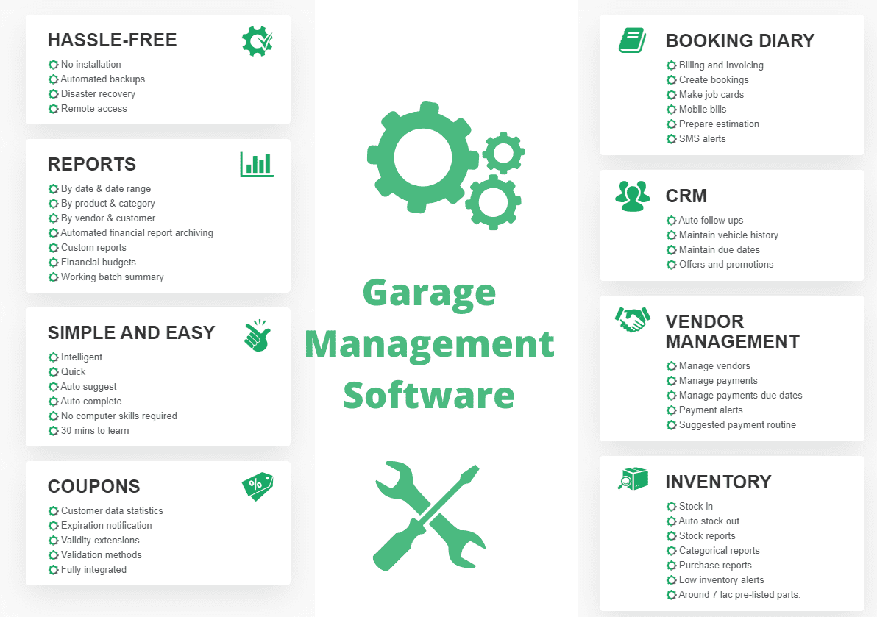

**OBJECTIVES :**

The main objectives of a garage management system (GMS) are to streamline operations, improve efficiency, enhance customer experience, and increase profitability by centralizing tasks like appointment scheduling, inventory management, customer tracking, and financial reporting into a unified platform. It automates manual work, reduces errors, provides data-driven insights for better decision-making, and builds customer loyalty through improved communication and service.

**DEVELOPMENT PHASE :**

* Creating Developer Account : By using this URL – <https://www.salesforce.com/form/developer-signup/?d=pb>

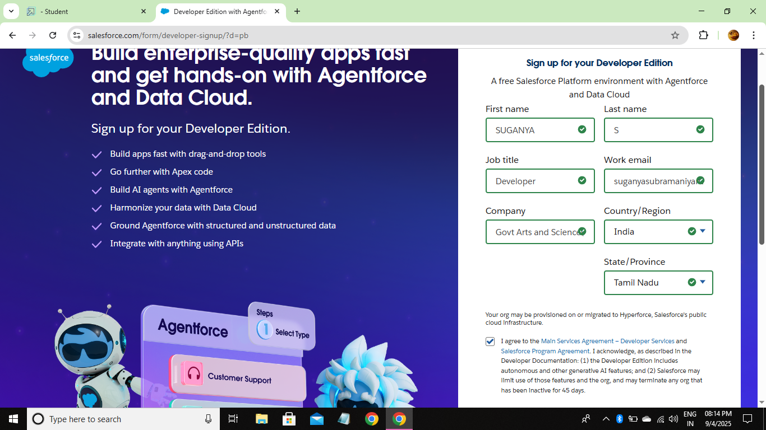

* Created Objects :

* Customer Details

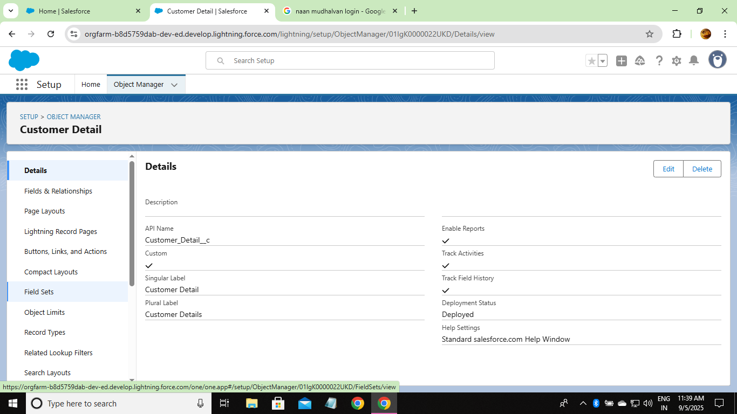

* Appointment

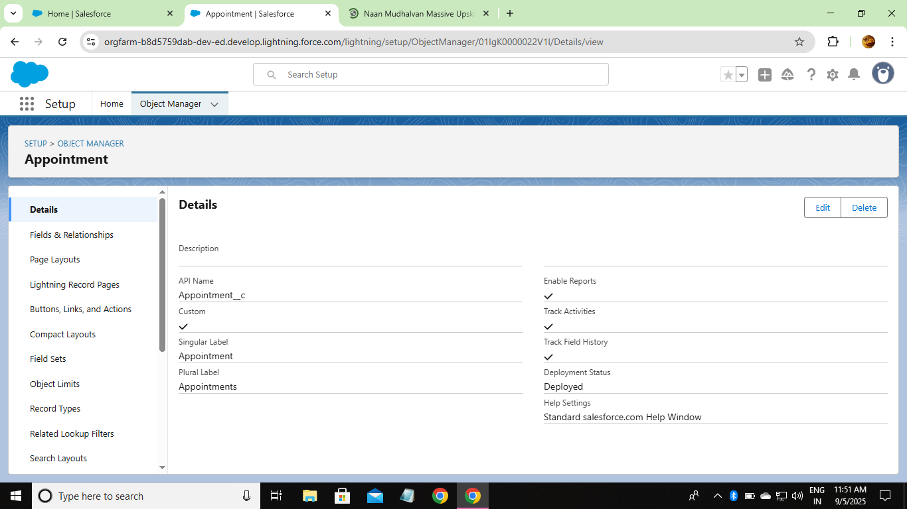

* Service Record

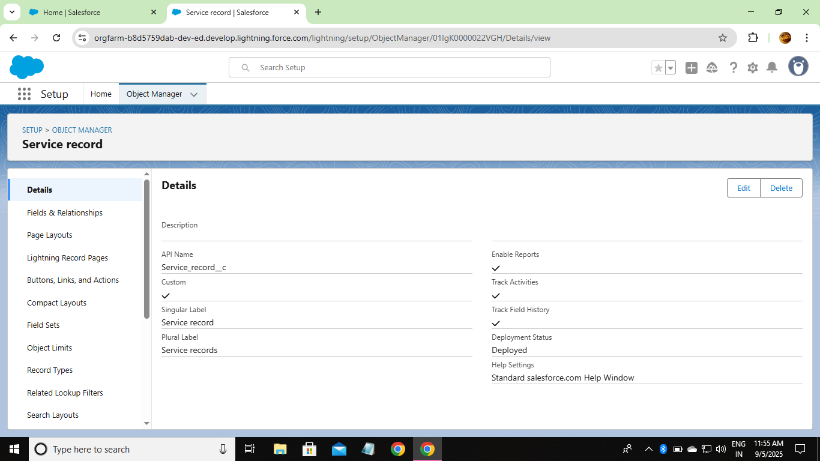

* Billing Details and Feedback

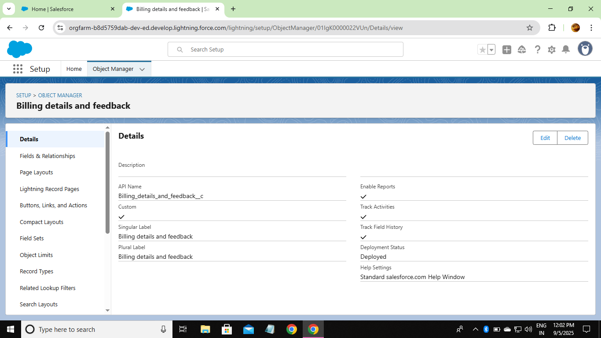

* Created Custom Tabs :
* Customer Details
* Appointment
* Service Record
* Billing Details and Feedback

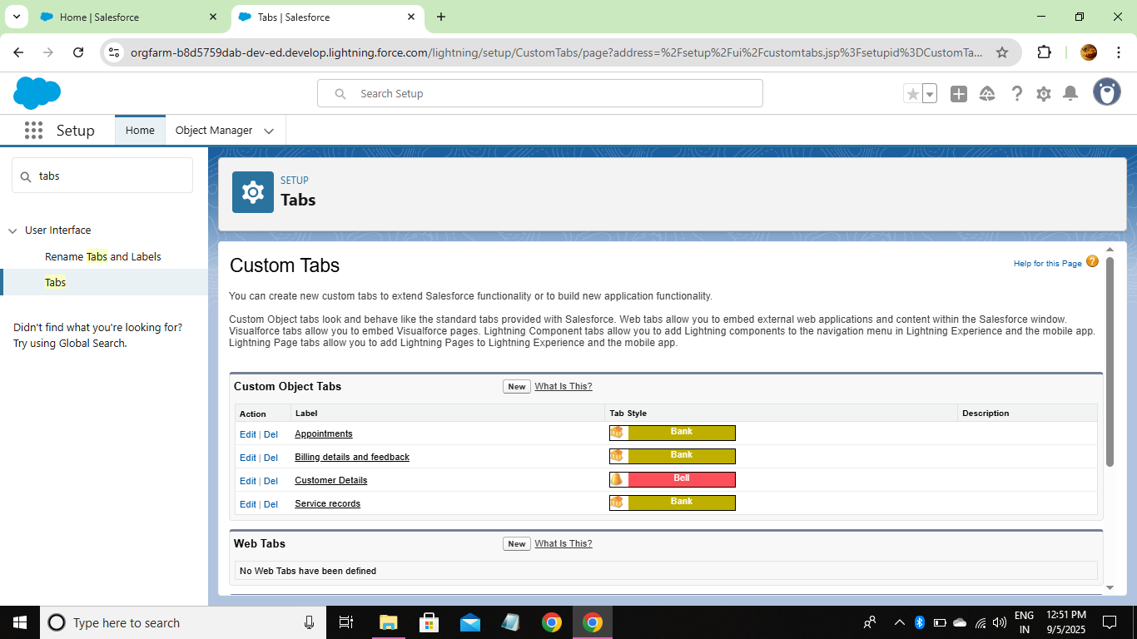

* Developed Lightning App :

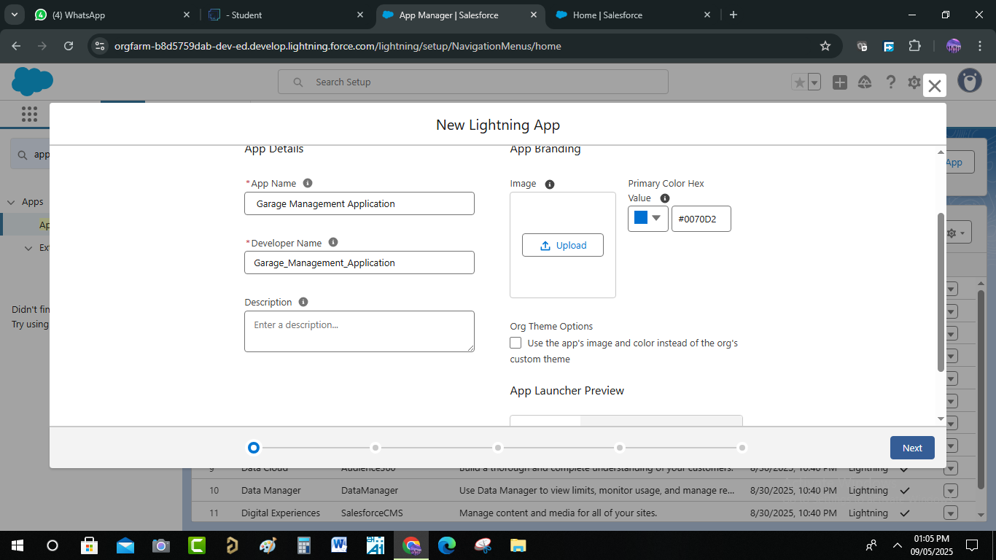

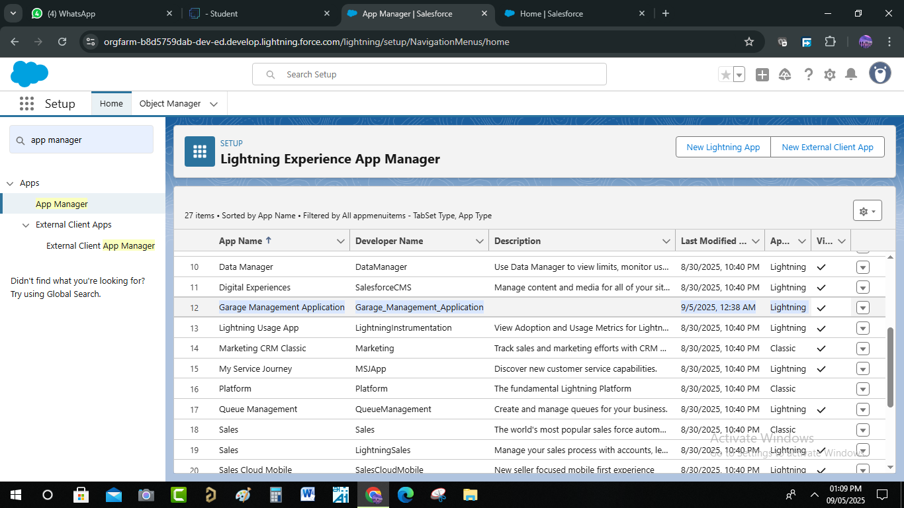

* Created Fields :
* Customer Details Object

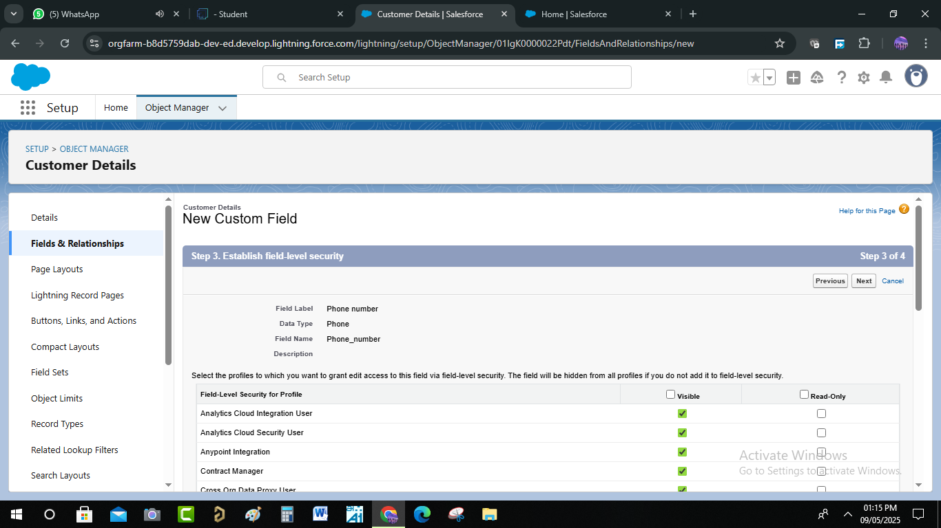

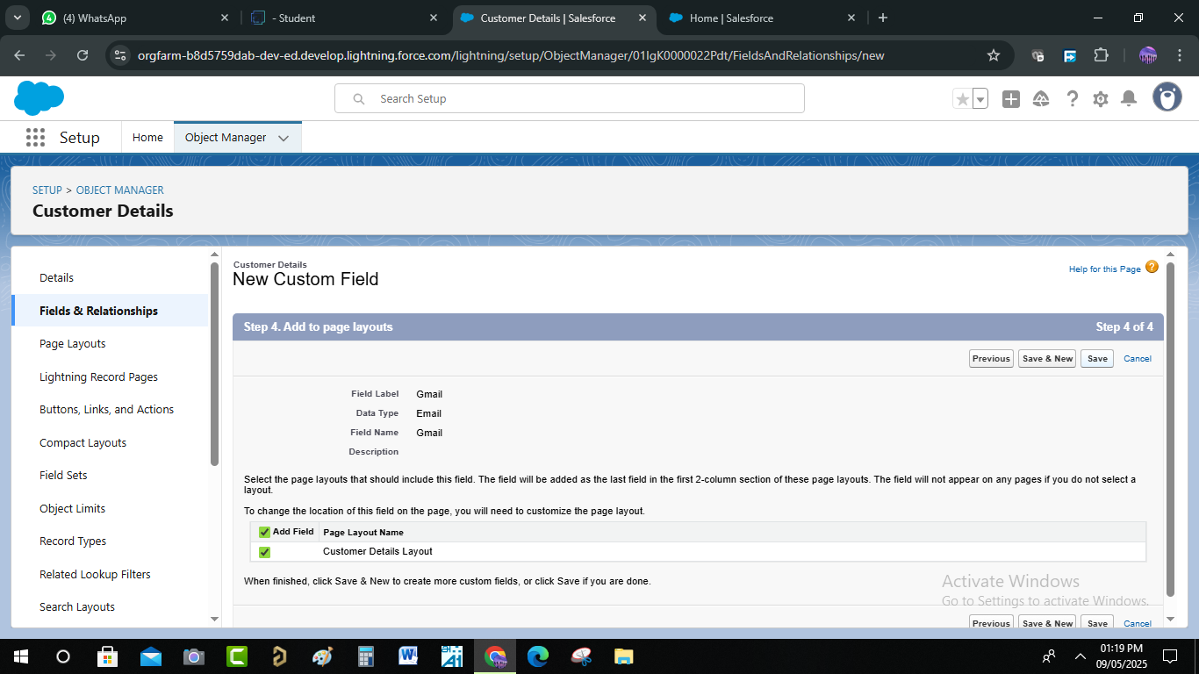

* Lookup Fields

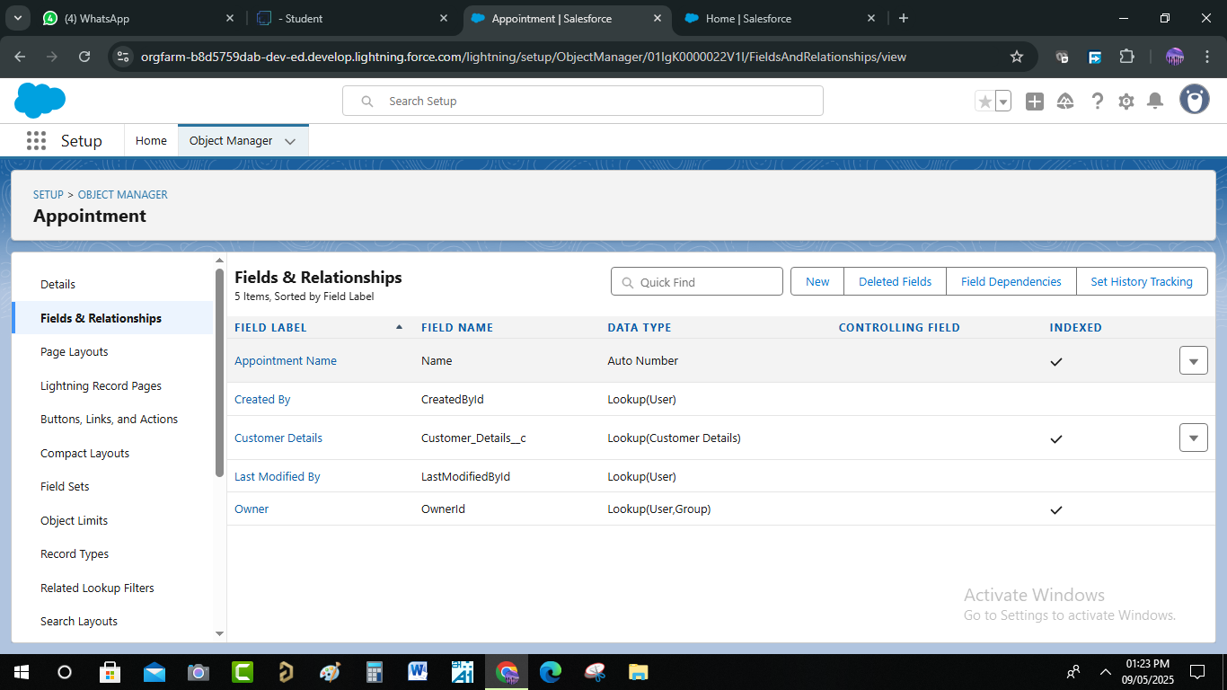

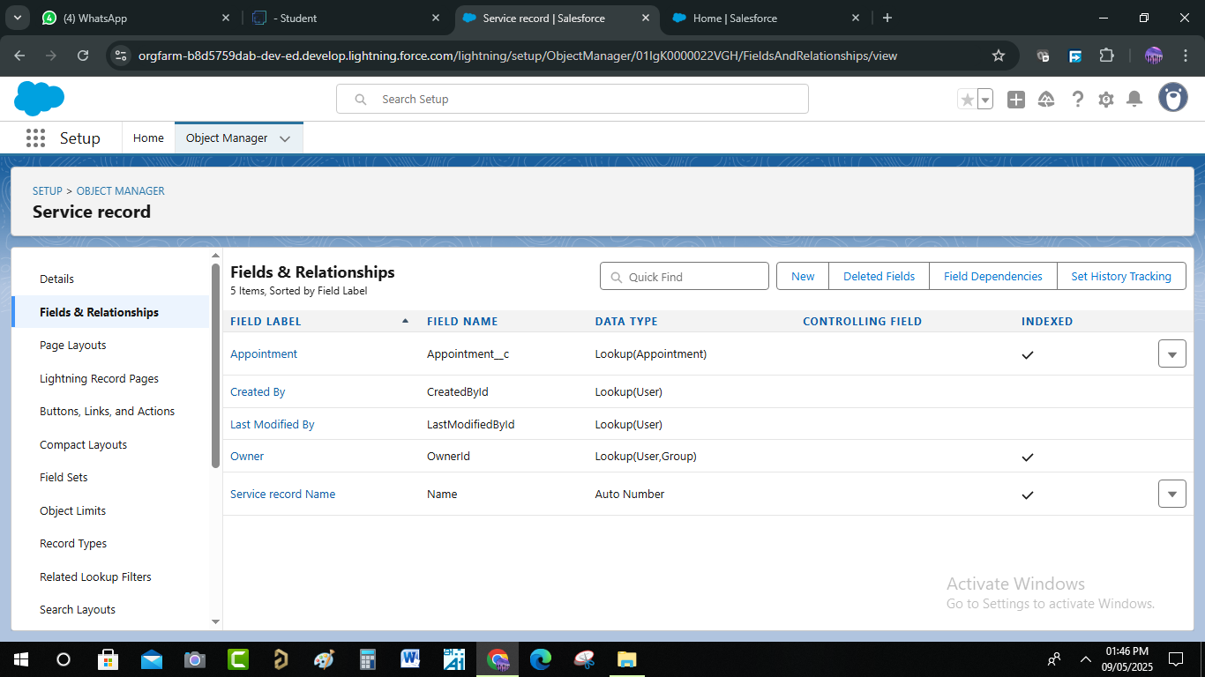

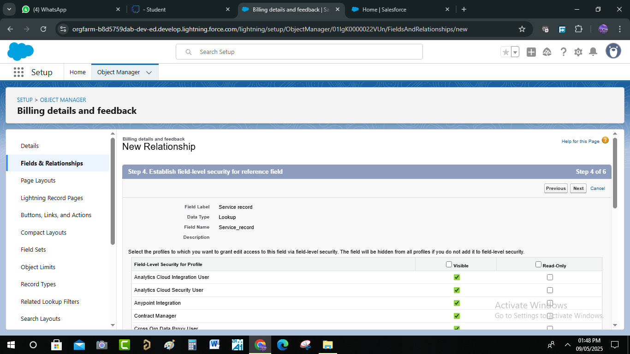

* Checkbox Fields

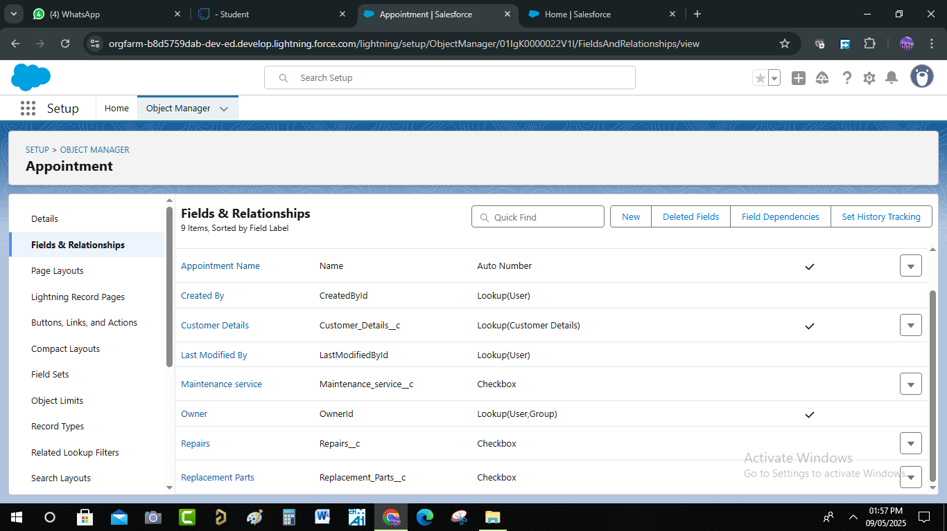

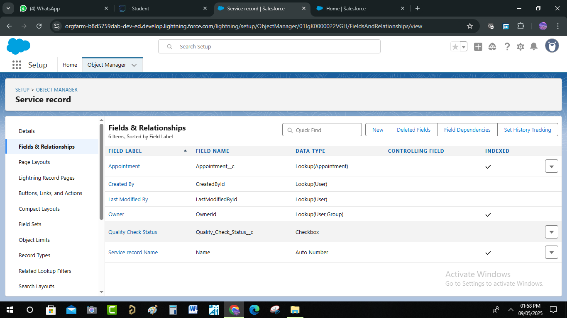

* Date Fields

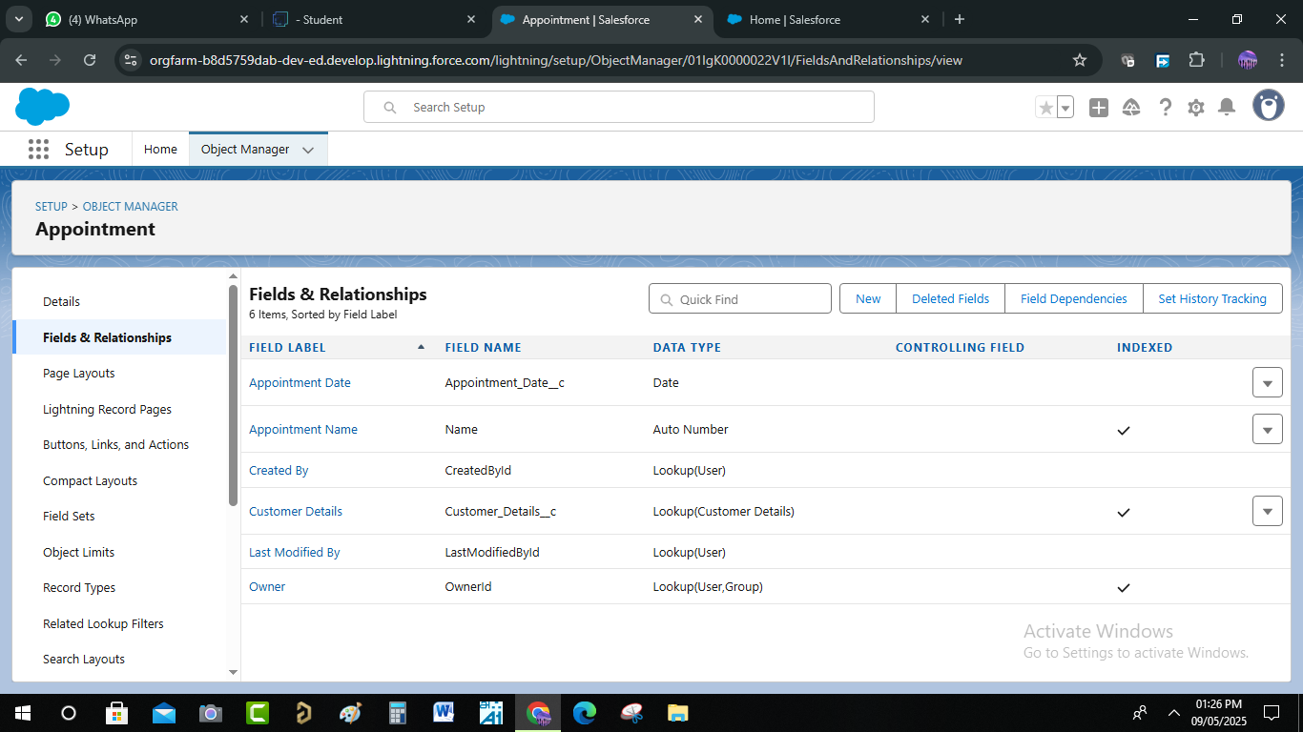

* Currency Fields

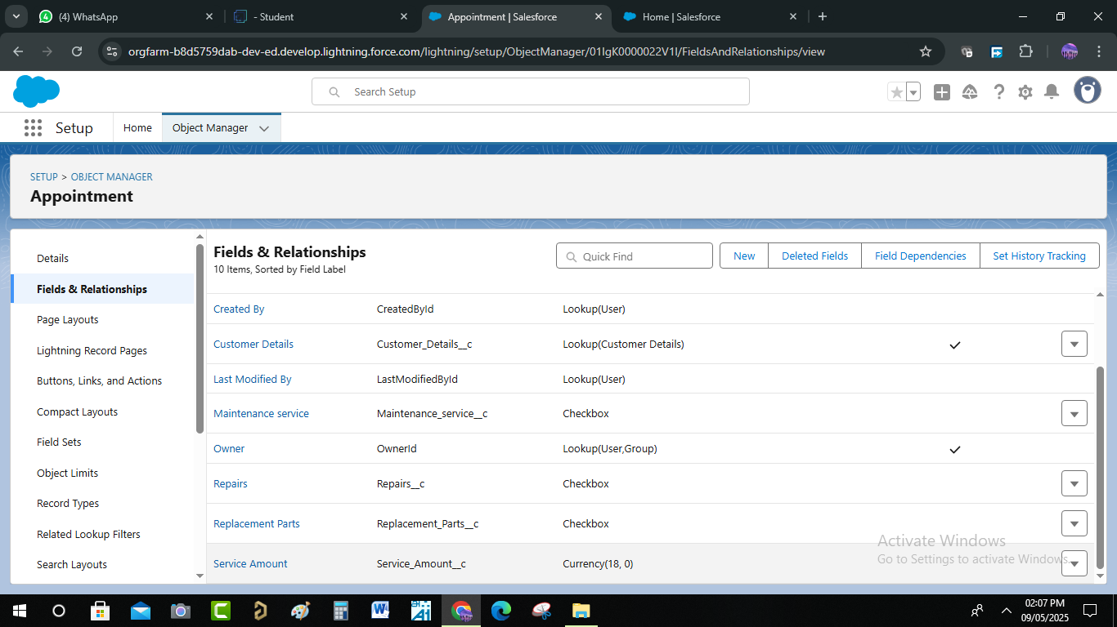

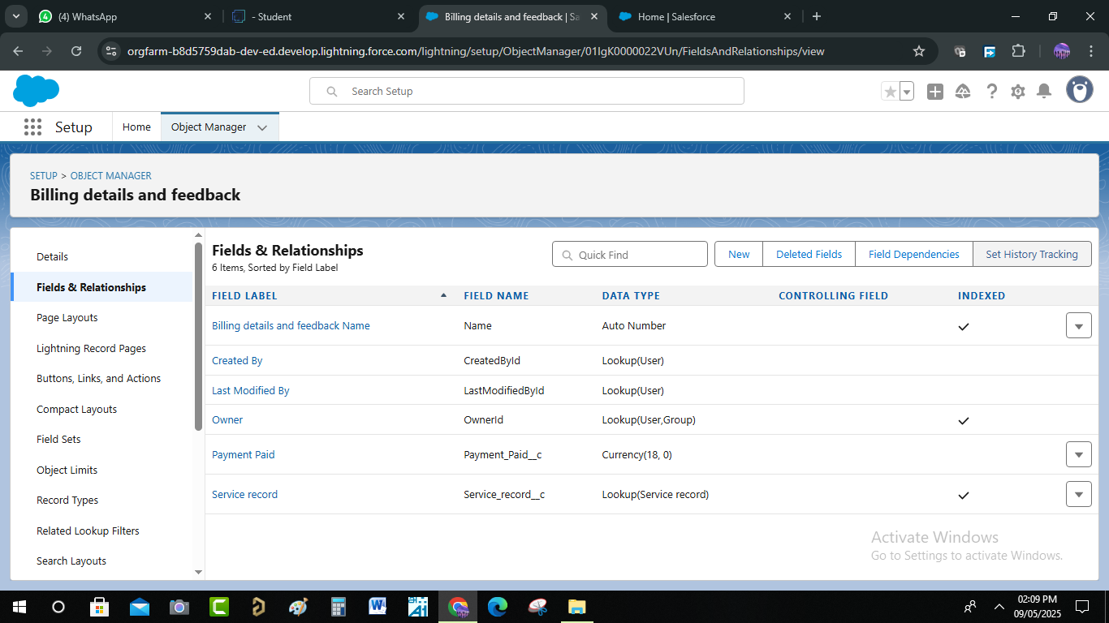

* Text Fields

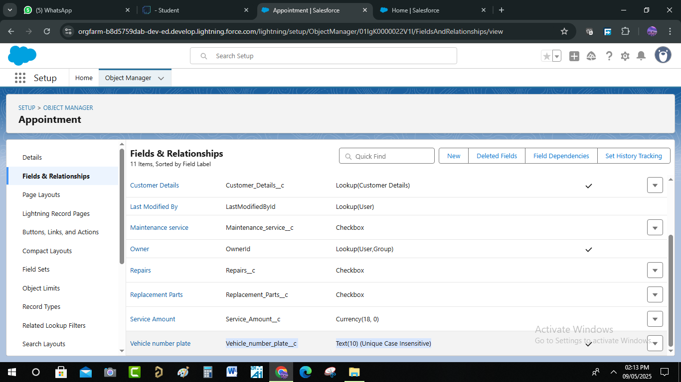

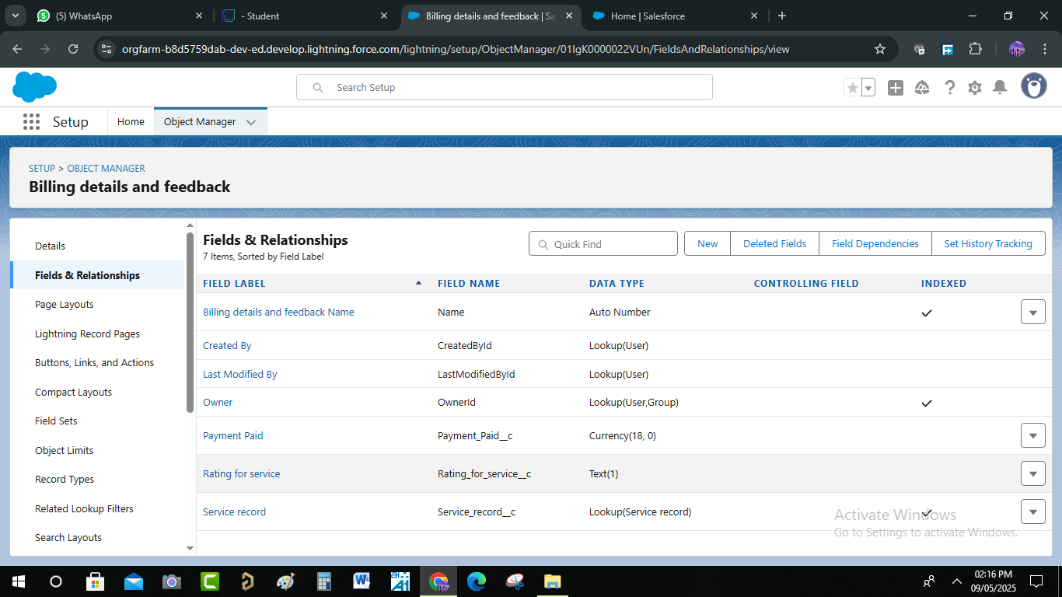

* Picklist Fields

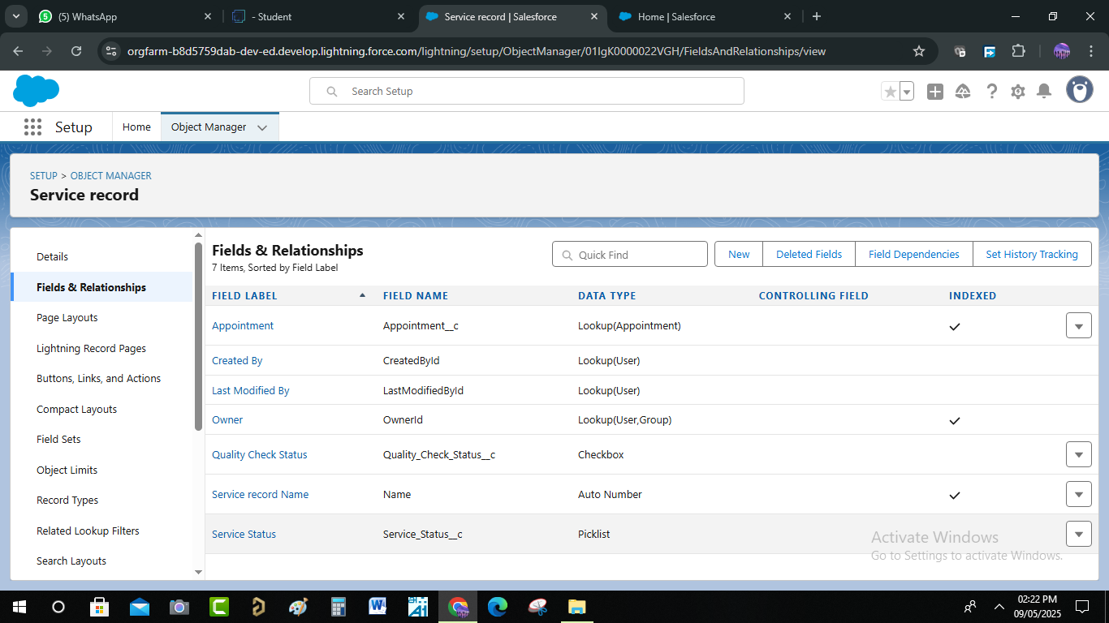

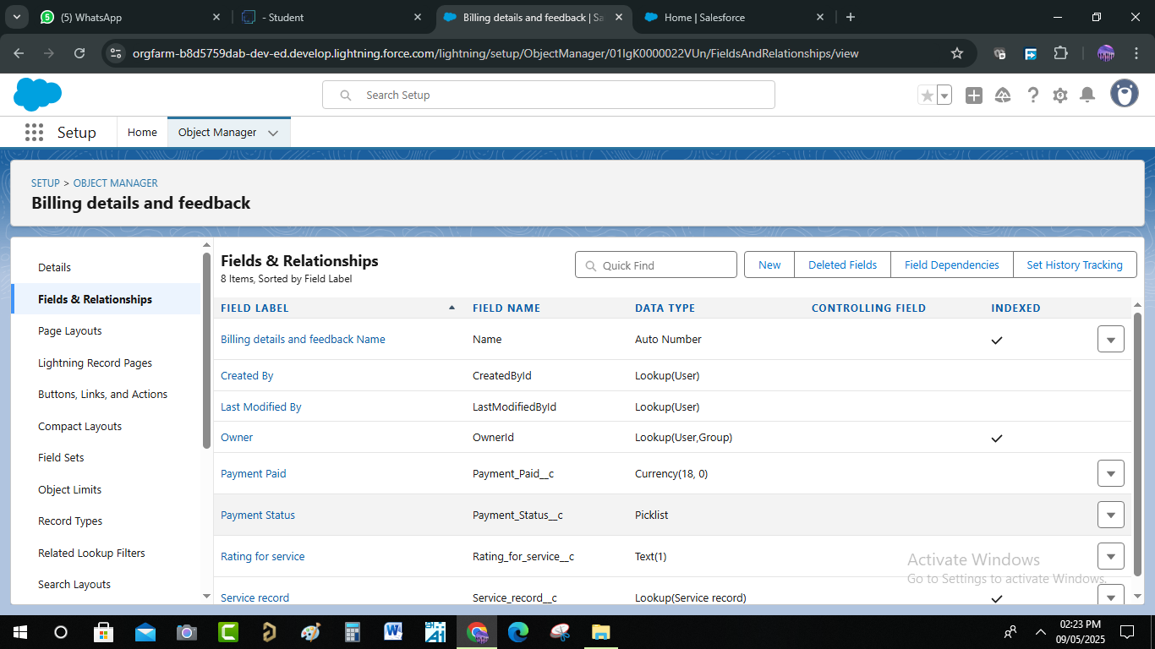

* Formula Field In Service Record

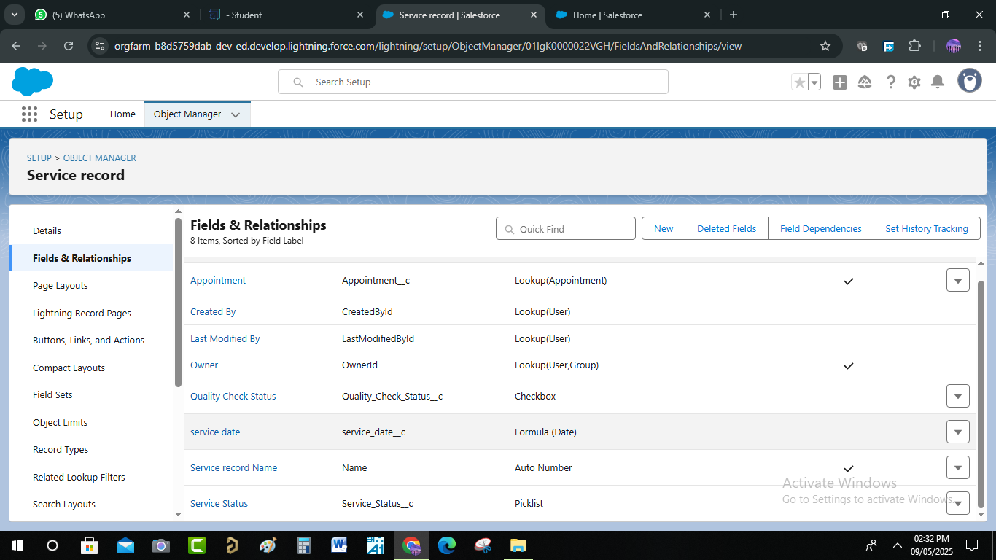

* Validation Rule :

Validation in a GMS ensures that the data entered into the system is accurate, complete, and reliable. It prevents errors such as duplicate entries, incorrect service details, or invalid customer/vehicle information**.**

**Typical validations include:**

* Customer Data Validation – checks if contact details, email, and phone numbers are valid.
* Vehicle Information Validation – verifies vehicle number, model, and service history consistency.
* Service & Appointment Validation – ensures correct service selection, valid dates/times, and no double booking.
* Payment Validation – confirms correct billing amounts, payment modes, and invoice generation.
* System Validation Rules – prevent missing mandatory fields and enforce business rules (e.g., warranty claims only for eligible vehicles).
* A Validation Rule To An Appointment Object

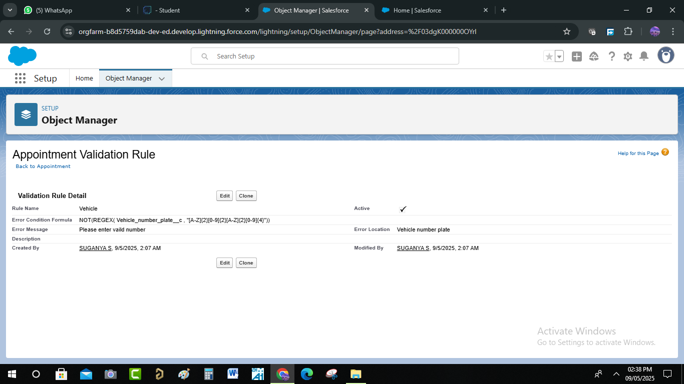

* A Validation Rule To An Billing Details And Feedback Object

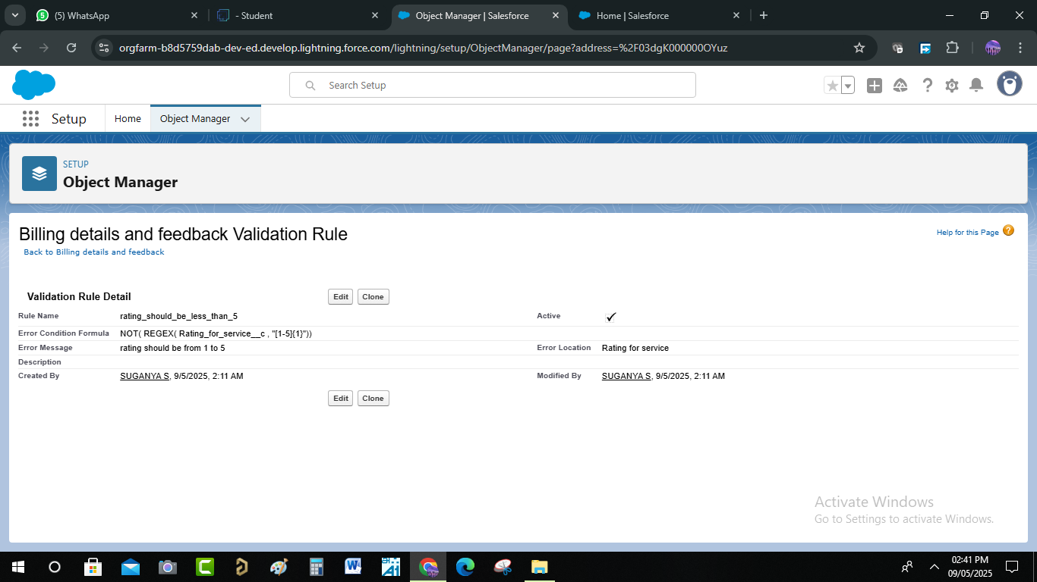

* Duplicate Rule :
* **A** Matching Rule To An Customer Details Object

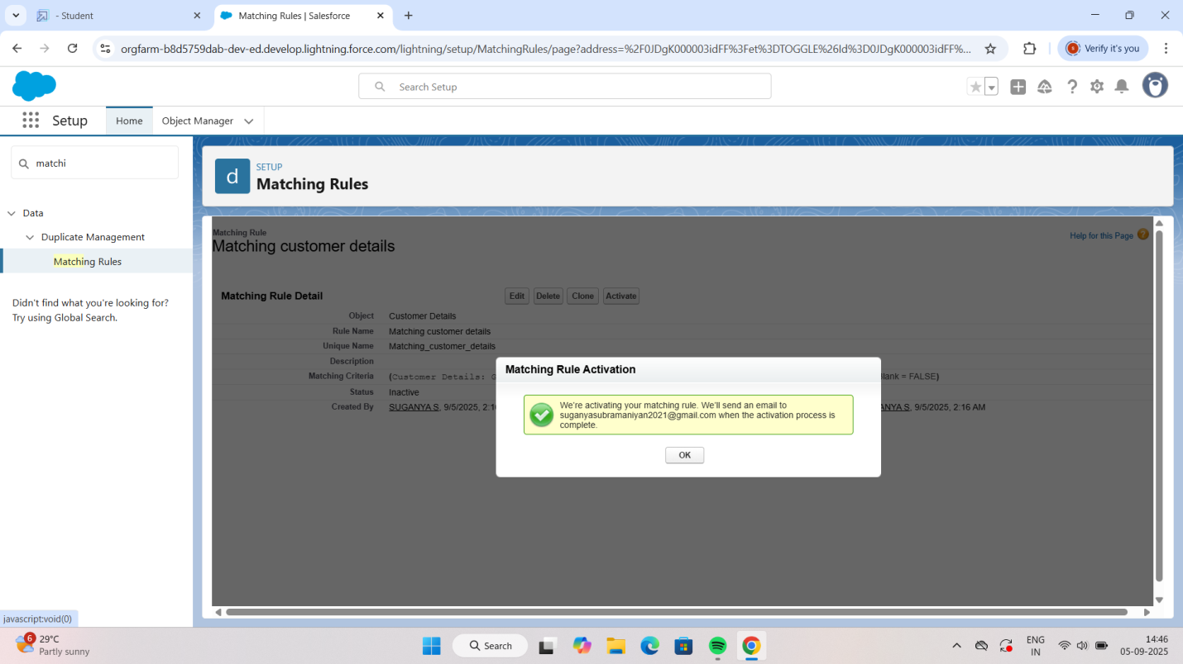

* A Duplicate Rule To An Customer Details Object

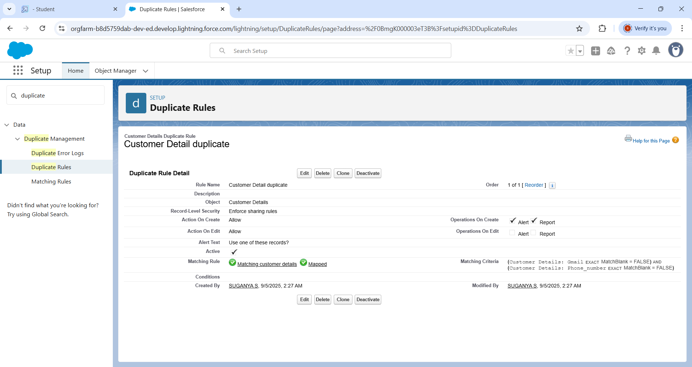

* Created Profiles :
* Manager Profile

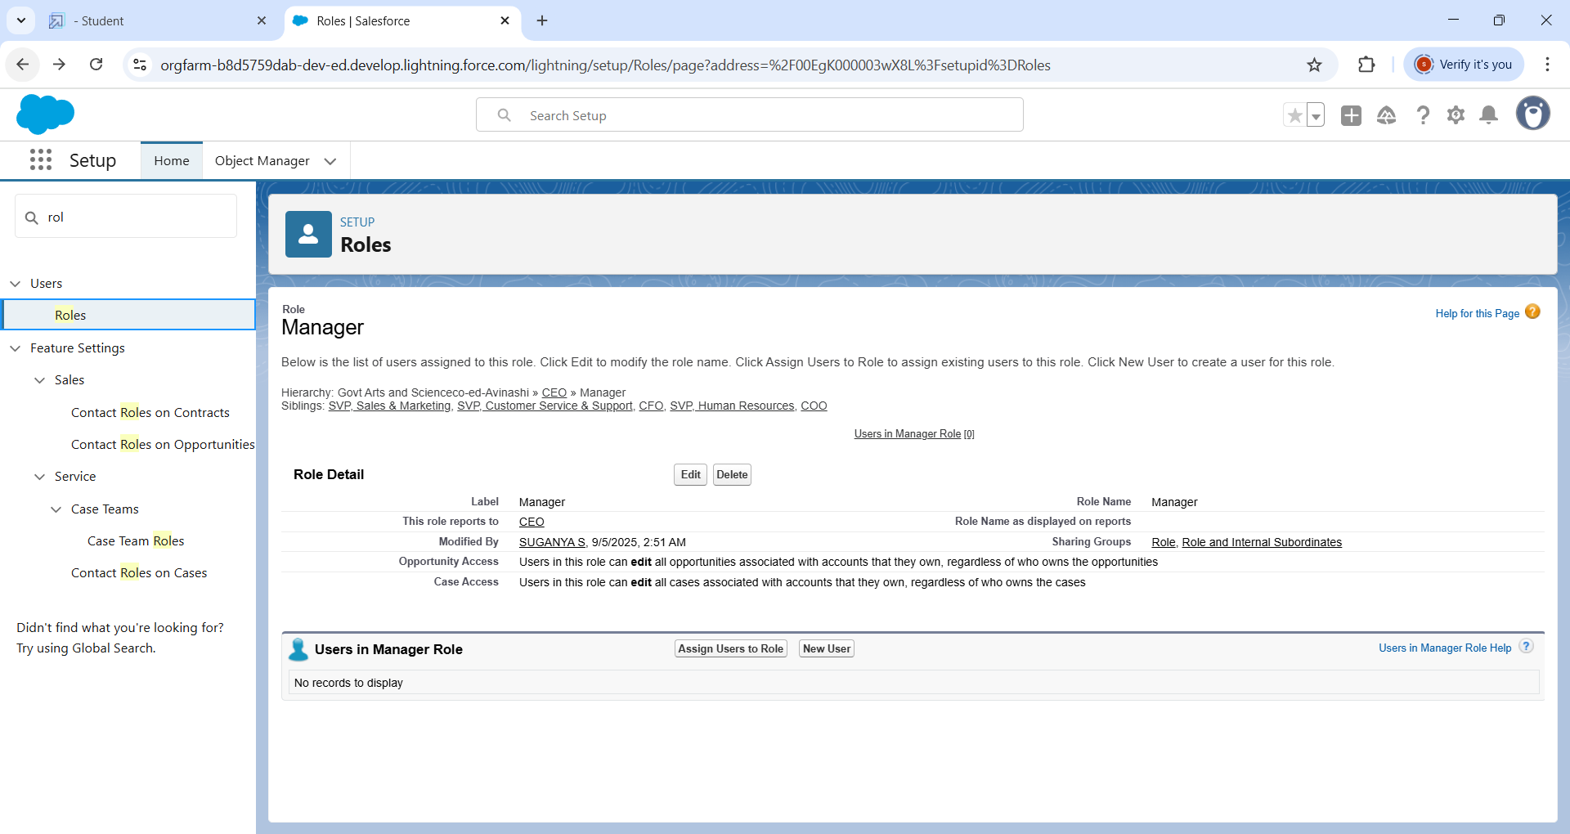

* Sales Person Profile

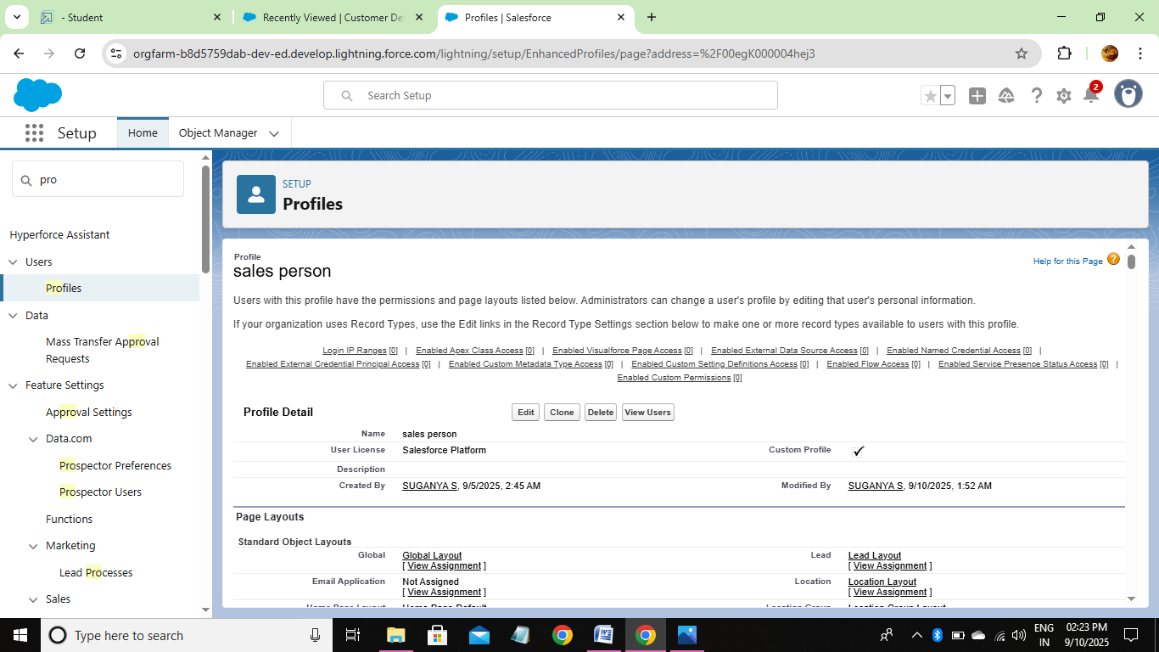

* Role & Role Hierarchy :
* Manager role



* Another roles

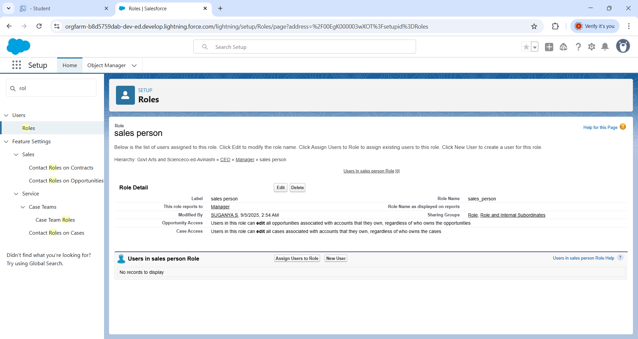

* Created Users :
* User

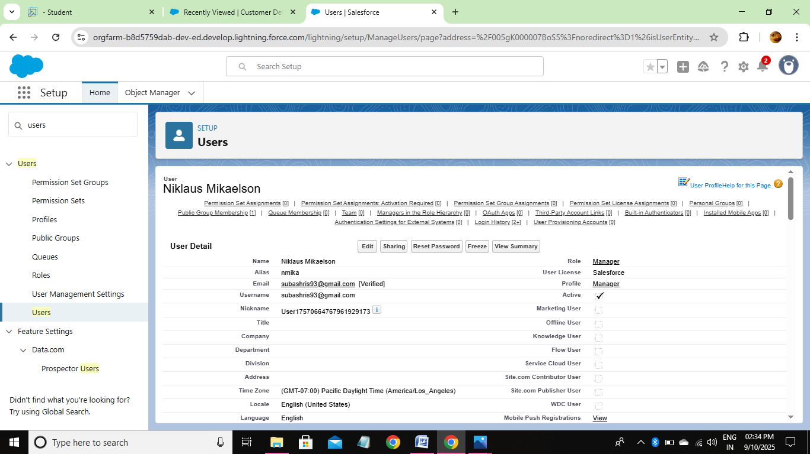

* Another Users

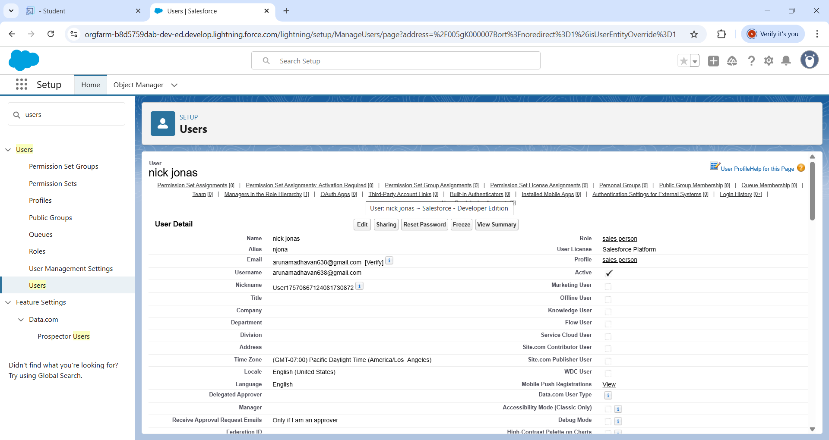

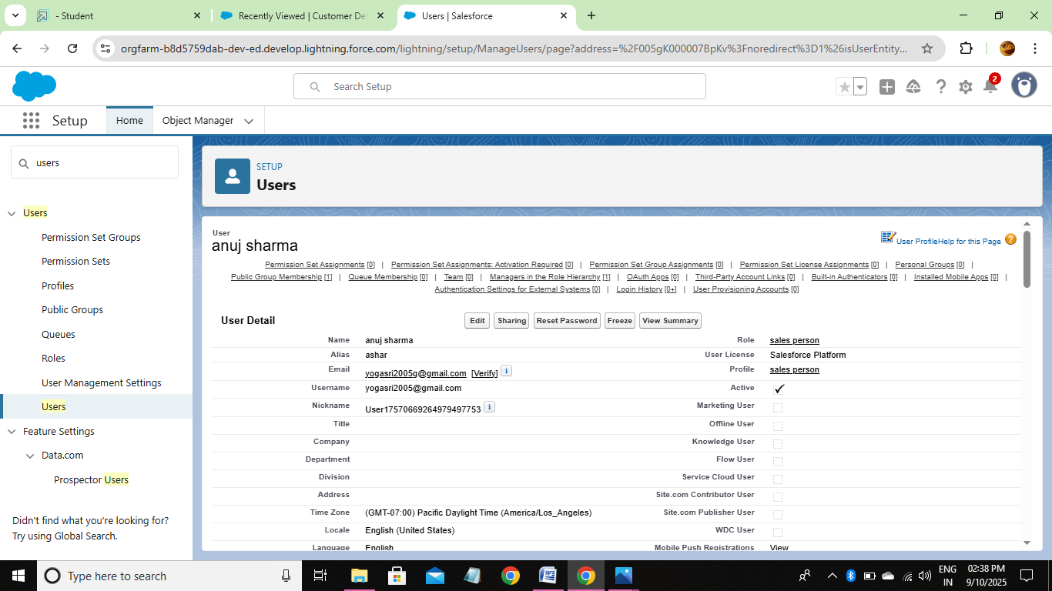

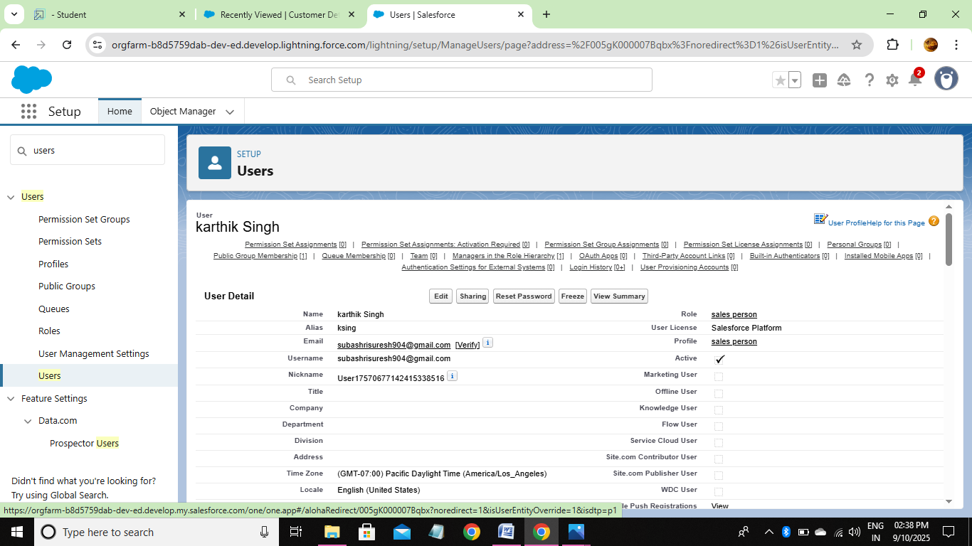

* Public Groups :

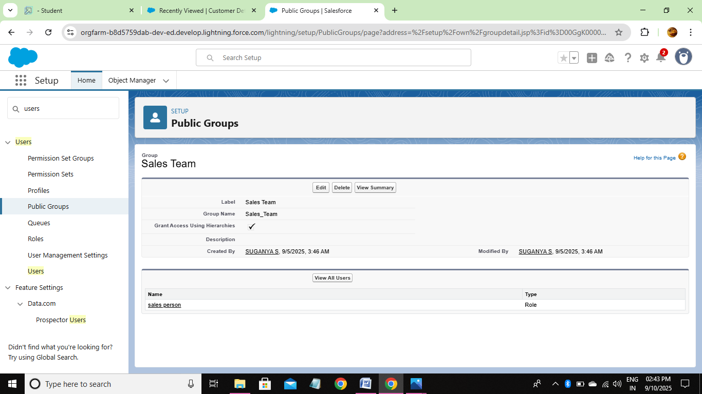

* Sharing Settings :

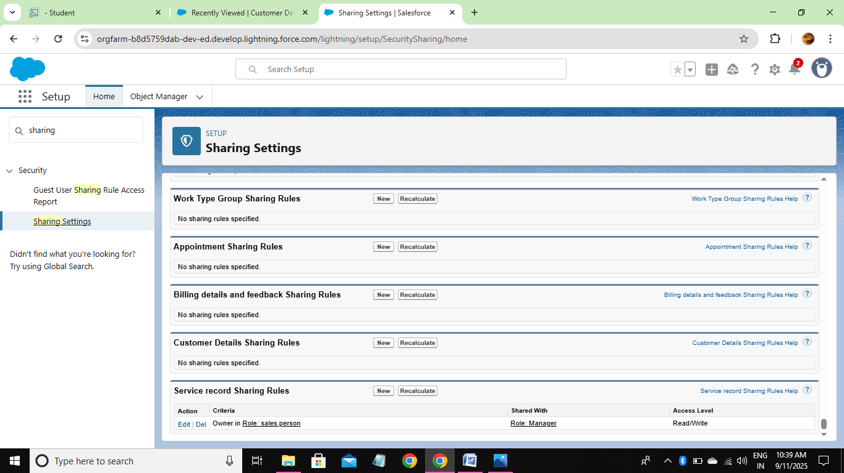

* Created Flows :
* Flow
* **Test Scenarios**
* Create new Billing record with valid Customer Email → Flow should update amount and send email.
* Create new Billing record without Customer Email → Flow should update amount but skip email alert.
* Update existing Billing record → Verify if email alert re-triggers or not (based on design).
* Invalid email format → Flow should log error or not send email.
* High data volume (bulk test) → Insert/update 50+ Billing records and check if flow runs without hitting limits

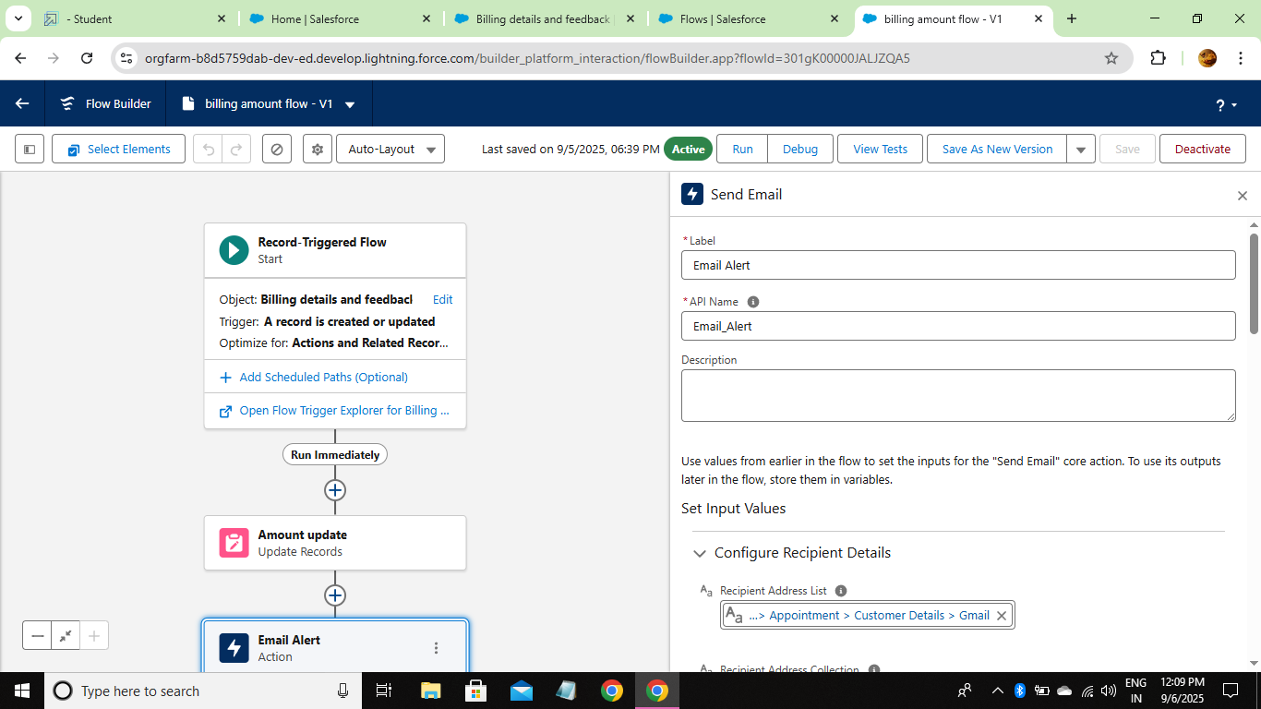

* Another Flow
* **Test Scenarios**
* Create a new Service Record with valid data → Flow should update Service Status/Amount correctly.
* Update an existing Service Record → Check if status is updated as per rules.
* Update record with no change in relevant fields → Flow should not perform unnecessary updates.
* Missing critical field (like Service Type) → Flow should handle gracefully.
* Bulk test (insert/update 50+ service records) → Flow should complete without errors.

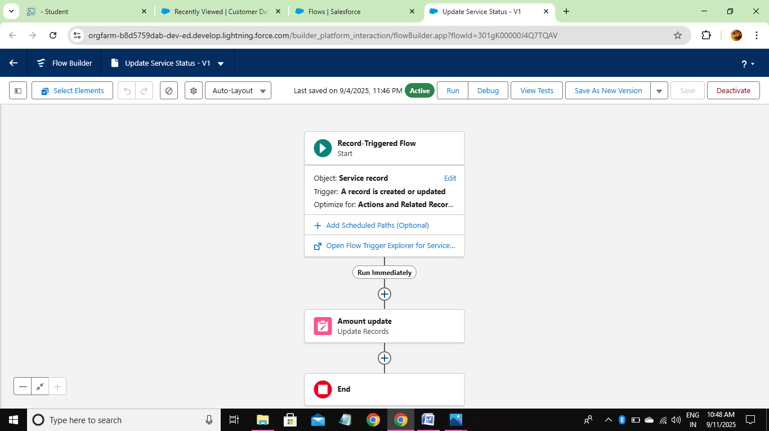

* Apex Trigger :
* Apex Handler

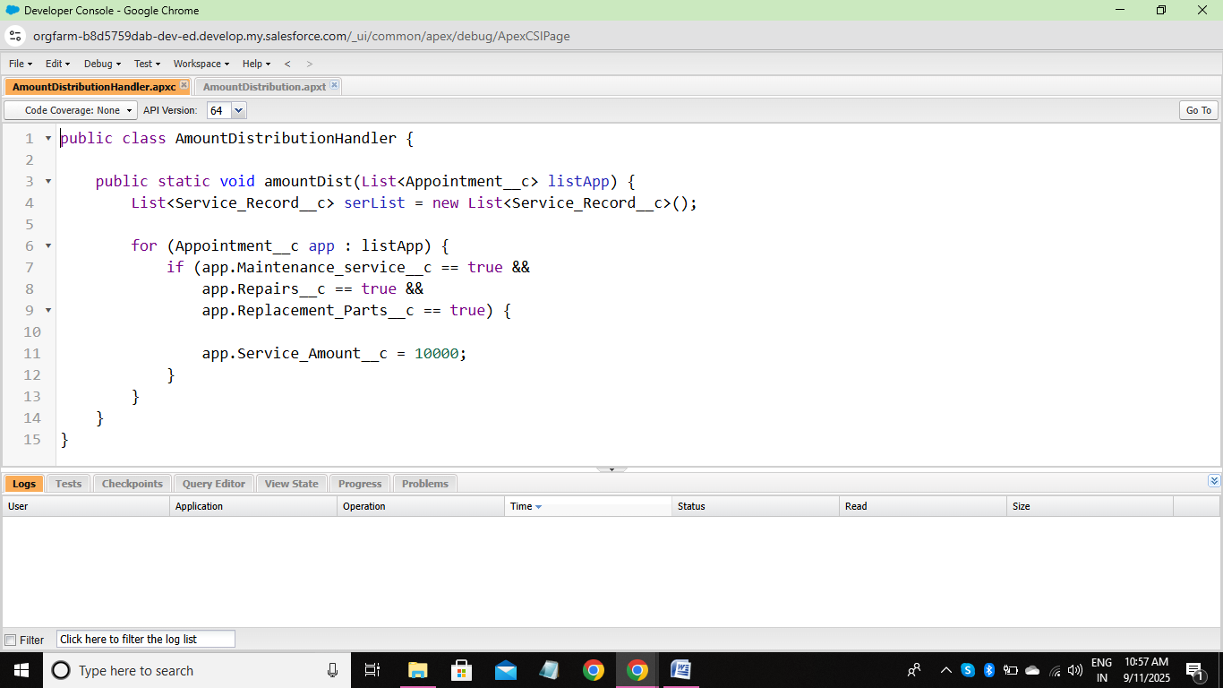

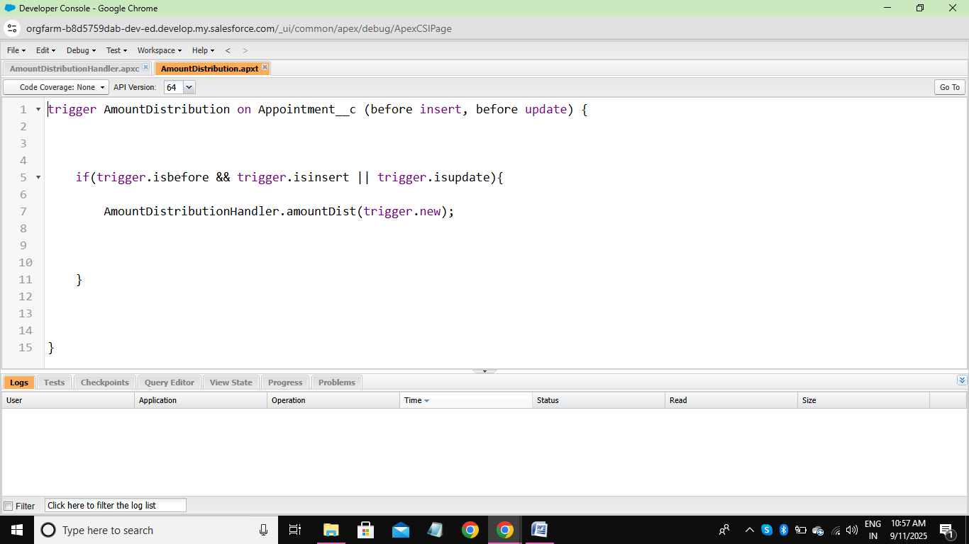

* Created Reports :
* A Report Folder
* **Test Scenarios**

1. Folder Creation

* Create a new report folder.
* Validate folder name uniqueness.
* Ensure default folder is visible.

2. Folder Permissions

* Share folder with specific users/roles.
* Test read-only vs. edit access.
* Verify restricted users cannot access.

3. Folder Operations

* Rename an existing folder.
* Delete a folder with/without reports.
* Move reports between folders.

4. Report Management

* Add reports into folder.
* Open reports from the folder.
* Validate report visibility after moving.

5. Negative Testing

* Attempt creating duplicate folder names.
* Try deleting a folder without permission.
* Access reports in a folder without proper rights.

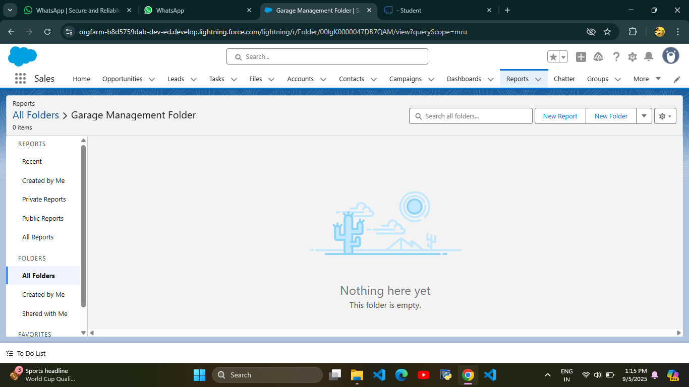

* Sharing A Report Folder
* **Test Scenarios**

1. Folder Sharing

* Share a folder with a specific user verify user can access.
* Share with a role (e.g., Manager) → all role members should get access.
* Share with a public group → confirm access for group members.

2. Access Levels

* Assign Viewer access → user can only view reports.
* Assign Editor access → user can view and edit reports.
* Assign Manager access → user can view, edit, and re-share folder.

3. Permission Validation

* Remove sharing access → user should lose folder visibility.
* Downgrade access (Manager → Viewer) → confirm restrictions apply.
* Test overlapping permissions (user in multiple roles with different rights).

4. Negative Testing

* Try to share with invalid users.
* User without access should not see the folder in their list.
* Check unauthorized user cannot open reports via direct link.

5. Test Data

* Users with different roles: Admin, Manager, Mechanic, Guest.
* A sample report folder with multiple reports.
* Public group (e.g., ServiceTeam).

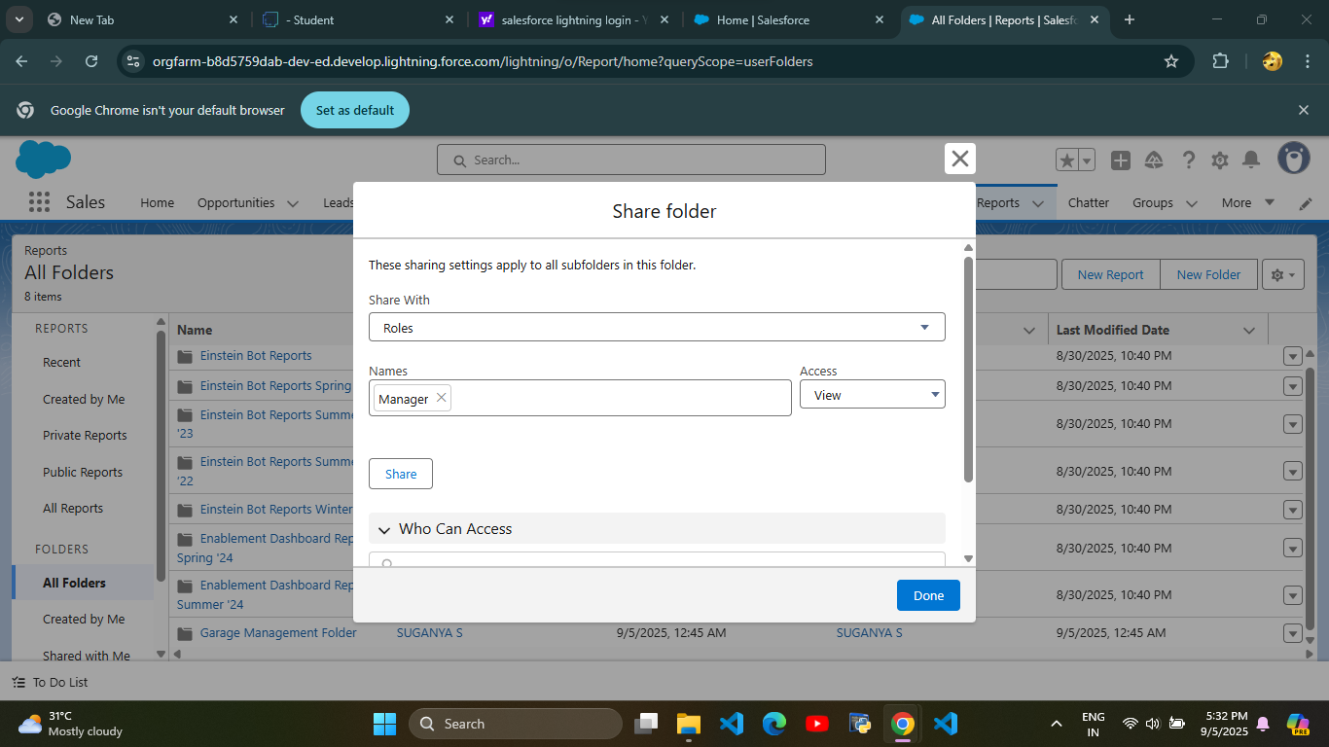

* Report Types
* **Test Scenarios**

1. Creation & Configuration

* Verify that a new custom report type can be created successfully.
* Ensure the display label, API name, and description are saved correctly.
* Check that the primary object and related objects are selectable as per business requirement.
* Validate object relationships (with or without related records).

2. Field Availability

* Ensure all fields of the primary and related objects are available in the report.
* Verify custom fields appear correctly.
* Check field-level security (restricted fields should not be visible).

3. Report Building

* Create a report using this custom report type.
* Validate the report loads with correct fields.
* Apply filters and confirm accurate filtering.
* Test sorting, grouping, and summary fields.

4. Data Validation

* Cross-check data in the report with raw records from Salesforce objects.
* Validate counts, sums, averages, and roll-ups.
* Confirm relationship joins fetch correct records (e.g., "with at least one related record" vs. "may or may not have").

5. Access & Permissions

* Verify report visibility based on user profiles/roles.
* Confirm restricted users cannot access unauthorized report types.

6. Usability

* Ensure naming conventions are meaningful.
* Check that users can easily identify and use the report type.

7. Negative Testing

* Try deleting fields from report type and confirm handling.
* Validate system behavior when objects/fields are deleted.
* Ensure invalid filter conditions return appropriate messages.

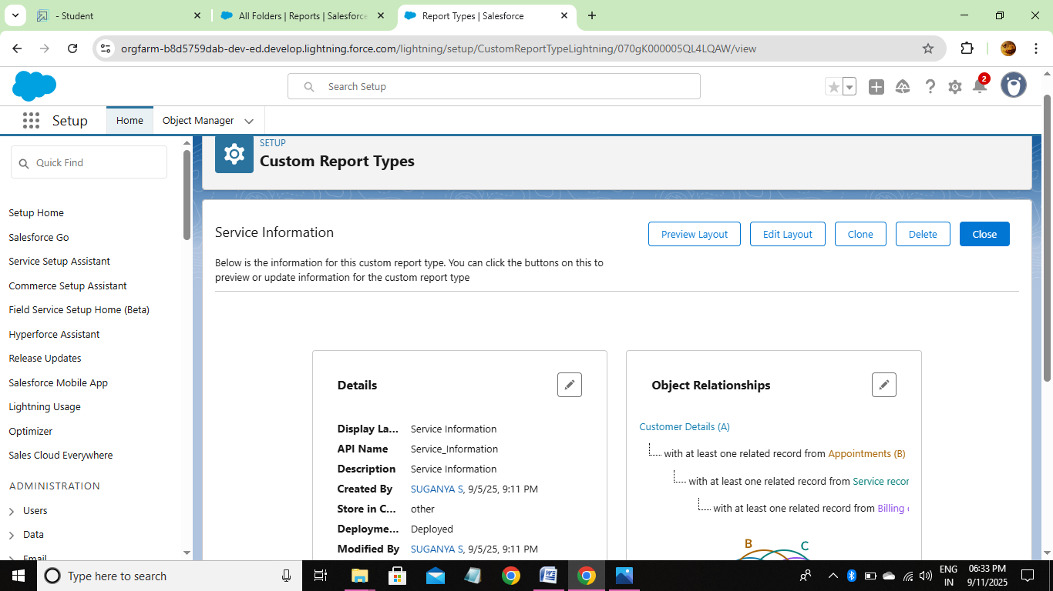

* Reports
* **Test Scenarios**

1. Functional Testing

* Create, edit, delete reports.
* Verify folders (Created by Me, Shared, Public, Private).
* Check search & filters.

2. Data Validation

* Ensure report data matches source records.
* Validate totals, counts, and calculations.

3. UI Testing

* Check layout, navigation, and scrolling.
* Verify report details (name, description, owner, date).

4. Security Testing

* Test role-based access.
* Confirm private reports aren’t visible to unauthorized users.

5. Performance Testing

* Measure load time with large datasets.
* Check system behavior under multiple users.

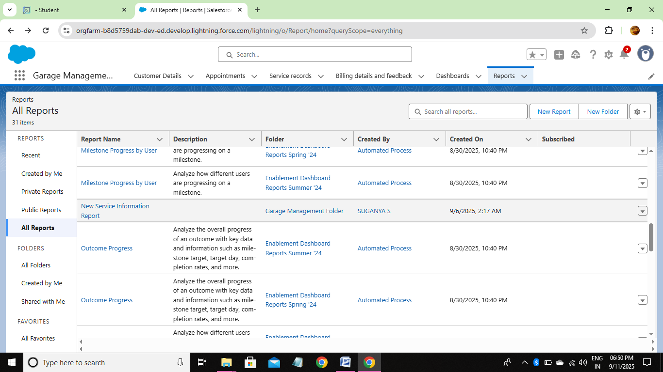

* Dashboards :
* Dashboard Folder

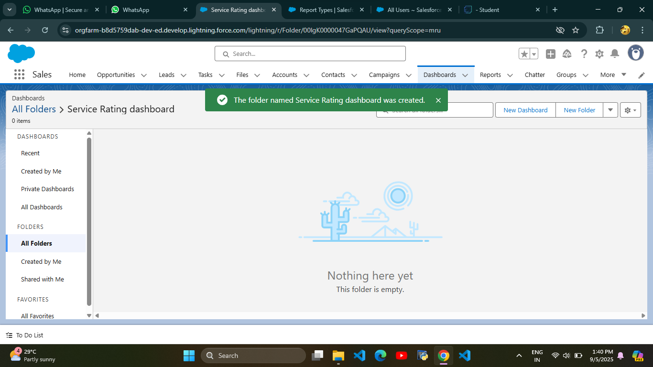

* Dashboard

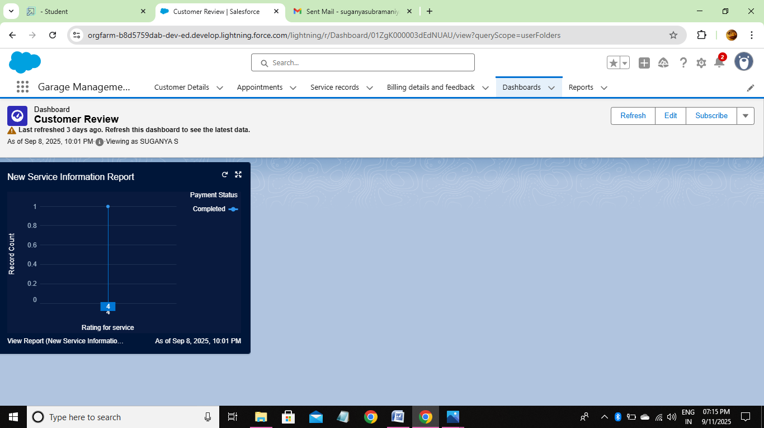

* Created Records :

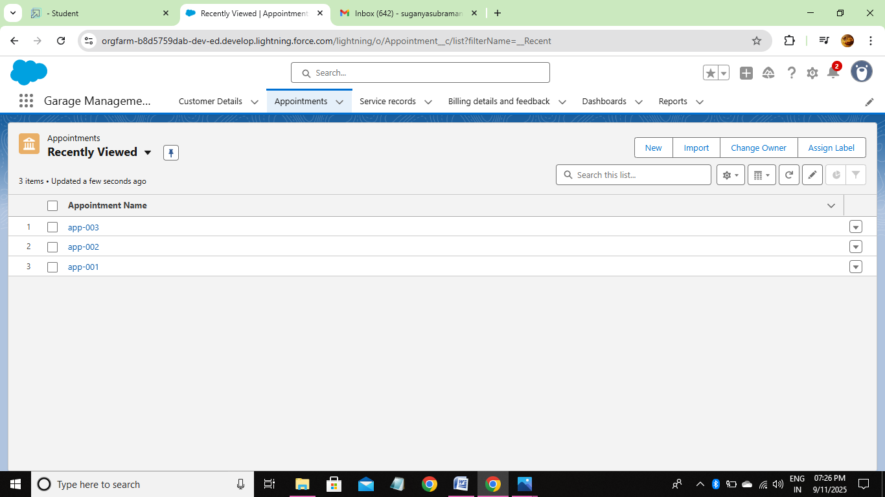

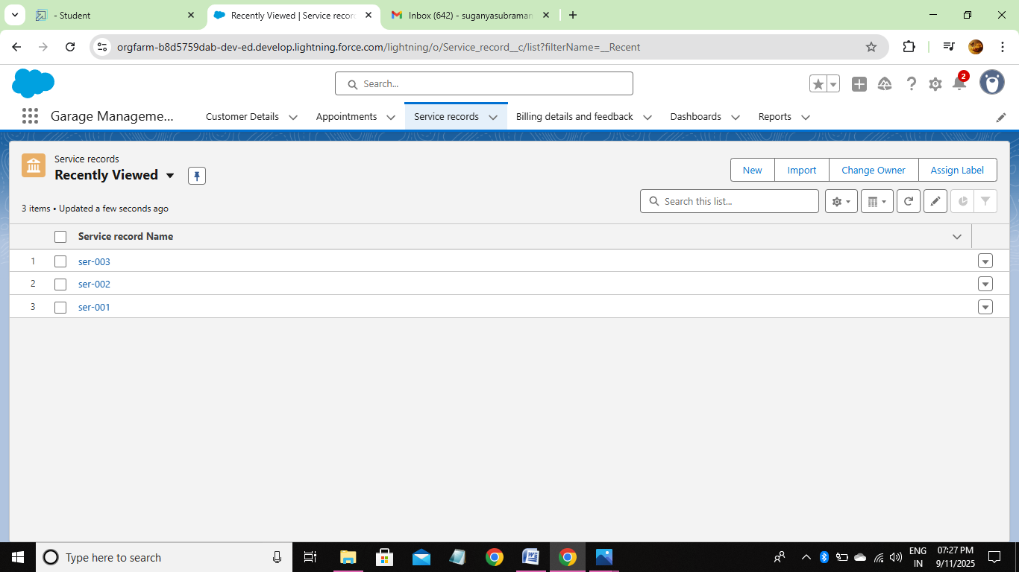

**ADVANTAGES :**

* **Efficient Vehicle & Service Tracking** – Maintains complete service and repair history for every vehicle.
* **Time & Cost Saving** – Automates routine tasks like billing, appointments, and inventory.
* **Improved Customer Service** – Provides reminders, transparent billing, and quick status updates.
* **Better Financial & Inventory Management** – Tracks expenses, revenues, and spare parts stock accurately.
* **Reporting & Analytics** – Generates useful reports for decision-making and performance improvement.

**DISADVANTAGES :**

* **High Initial Cost** – Setting up software, hardware, and training requires significant investment.
* **Technical Issues** – System crashes, bugs, or downtime can interrupt garage operations.
* **Training Requirement** – Staff need time and effort to learn the system effectively.
* **Data Security Risks** – Sensitive customer and financial data may be vulnerable to cyber attacks if not secured properly.
* **Dependence on Technology** – Heavy reliance on software means operations may slow down if the system fails or internet is unavailable.

**CONCLUSION :**

The Garage Management System effectively streamlines the operations of vehicle servicing and repair through a structured, automated Salesforce application. It enhances efficiency in managing appointments, service records, and billing, while improving communication between customers and staff.

**APPENDIX :**

**Source Code** : Provided in Apex Classes and Triggers

* **AmountDistributionHandler.apxc :**

public class AmountDistributionHandler {

    public static void amountDist(list<Appointment__c> listApp){

        list<Service_records__c> serList = new list <Service_records__c>();

        for(Appointment__c app : listApp){

            if(app.Maintenance_service__c == true && app.Repairs__c == true && app.Replacement_Parts__c == true){

                app.Service_Amount__c = 10000;

            }

            else if(app.Maintenance_service__c == true && app.Repairs__c == true){

                app.Service_Amount__c = 5000;

            }

            else if(app.Maintenance_service__c == true && app.Replacement_Parts__c == true){

                app.Service_Amount__c = 8000;

            }

            else if(app.Repairs__c == true && app.Replacement_Parts__c == true){

                app.Service_Amount__c = 7000;

            }

            else if(app.Maintenance_service__c == true){

                app.Service_Amount__c = 2000;

            }

            else if(app.Repairs__c == true){

                app.Service_Amount__c = 3000;

            }

            else if(app.Replacement_Parts__c == true){

                app.Service_Amount__c = 5000;

            }

    }

    }

}

* **AmountDistribution.apxt :**

trigger AmountDistribution on Appointment__c (before insert, before update) {

    if(trigger.isbefore && trigger.isinsert || trigger.isupdate){

        AmountDistributionHandler.amountDist(trigger.new);

    }

}

*****